Fabric Defect Detection System
Software project summary report
Number：-FDDS-CLOSUREREPORT
Version:1.0

Group： | Eleven | Date： | 2023-5-27
Approver： | Liu Jin | Date： | 2023-6-1

Change record
Date | Version | Change Notes | Group
2023-5-27 | 1.0 | Created the first version of the document | Eleven

Project Information
Project Name | Fabric defect detection system | Project Number | Eleven
Project Manager | All the member | Commit time | 2023-6-1

Project Description
2.1 Background
Artificial intelligence is a strategic emerging industry in China. With the continuous improvement and upgrading of various industries, industrial informatization has gradually been put on the agenda. AI plays an important role in informatization, which can replace human to complete some complex and time-consuming tasks in the past.
Fabric defect detection is an important part of production and quality management in the textile industry, and intelligent detection of fabric defects has been a technical bottleneck that has puzzled the industry for many years. Currently, almost all of the detection are manual tasks, which are susceptible to subjective factors and lack consistency; And long-term work under strong light has a huge impact on testers’ health. Using advanced technologies such as AI and CV to achieve intelligent detection of fabric defects is undoubtedly of great value.
2.2 Project Overview
This project aims to develop an online fabric defect detection system. It is mainly composed of an online detection module and a deep learning module. The online detection module provides an interface on which users can upload images for detection or generate images for performance testing. The deep learning module is mainly composed of corresponding models to provide defect detection function.
The system is developed by B/S architecture, and the entire system will be released together after completion, rather than individually for each module.
2.3 Technical advantage analysis of the project
Currently, both industry and academia have do a lot of research on generation models and target detection models, and have achieved excellent performance. Many fabric defect detection systems currently on the market also use the most advanced models. However, these advanced models are often difficult to reproduce and have a large number of parameters, which also require a lot of money to establish. Therefore, our system has chosen the most popular and stable model to provide a relatively reliable system with minimal investment.

Project Cycle Time
3.1 Project Progress Summary：
 | Plan | Practice | Deviation | Rate of deviation
Start Date | March 2 | March 2 | 0 | 0
End Date | May 27 | May 27 | 0 | 0
Period | Two | One | 50 | 50%

3.2 Cause of deviation：
Our group originally planned to do two rounds of loops and perform one iteration, but there was no iteration due to various reasons. There are two main reasons that led to our team not having time to carry out a round of iteration in the end. Because the team members got COVID-19 in the second half of the development, the second round of iteration was not carried out, and minor changes were made on the basis of the original project.
3.3 Measures for improvement：
Our team should make a detailed improvement plan at the beginning of the project, and make a possible improvement plan in the future according to the problems in the middle of the project, list the possible improvement directions, and find the problems that can be improved, instead of waiting until the end of the project to look for improvements. If a project needs to be repeated for multiple times, Because the plan should be iterative during the course of the project, planning as you go, you should not be inflexible and completely adhere to the plan at the beginning.

Software development and management processes

Process description
The process used | Tailoring Instructions
Standards Development | No Tailoring

Project outline design
·Project Structure
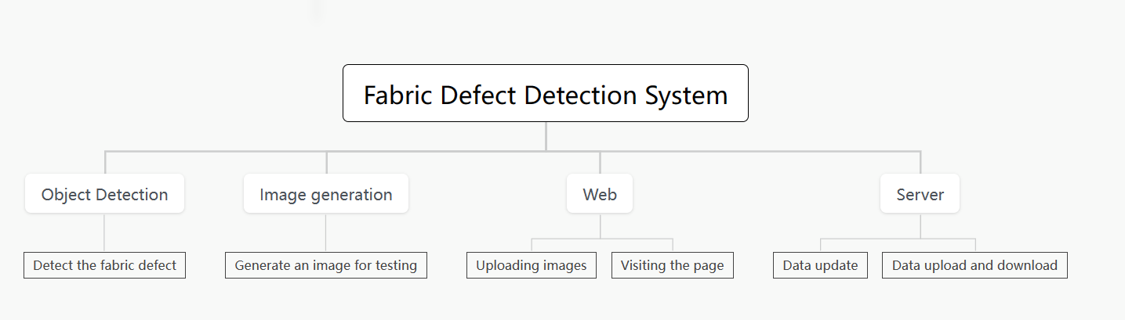
The most important function of this system is to realize the object detection module.This system uses the object detection module to detect fabric defects. The model used in the object detection module is yolov5.The secondary function of our system is to use the generative model to assist the object detection module.
This system needs a carrier to display the predicted and generated results of the model, so we choose to develop a webapp with B/S architecture to display the prediction and generated results. The B/S architecture is chosen because the current mainstream webapp is this architecture, and users only need to use a browser to access our website to obtain services, which greatly improves the user experience.
The web of this system is implemented with Vue.js, which is a Javascript framework for building user interfaces. It is built based on HTML,CSS and Javasccript, and provides a set of declarative and component-based programming models to help users develop user interfaces in a funny way.
The system server is written in java, and Springboot is used to build the whole server. Spring Boot is a new framework from the Pivotal team that's designed to simplify the initial process of building and developing Spring applications. The framework uses a specific way to do configuration so that the developer does not need to define boilerplate configuration. In this way, Spring Boot is committed to becoming a leader in the burgeoning field of rapid application development.

Project detailed design
The object detection module of the project, that is, the module improved on yolov5 for specialized detection of fabric defects, is synchronized with the Gan generation network module. Different members of our team design different modules.
The first is the detailed design of object detection. According to the understanding of the data set, our group decided to use the classic object detection model of yolov5 when making plans, so the object detection module was improved on the most basic yolov5 model, and our group did not carry out a lot of data enhancement. Here are the design steps:
Step 1: To install yolov5, use the command shown to install the latest version of yolov5 on github.
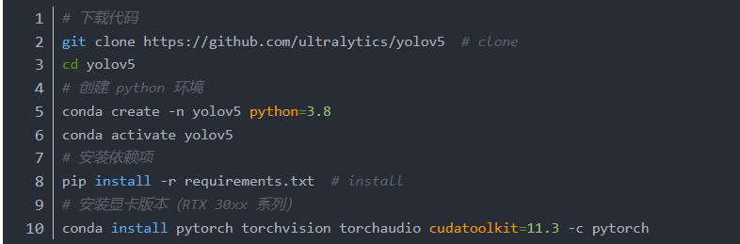
Step 2: Download the initial data set, change the data set and save the path as shown in the figure, create the train_data folder in the root directory of the project, and extract and save the data set as shown in the figure below
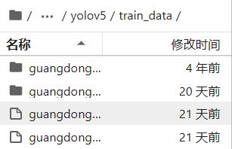
Step 3 Create an image classification and label conversion file convertTrainLabel.py in the root directory (see the code archive).
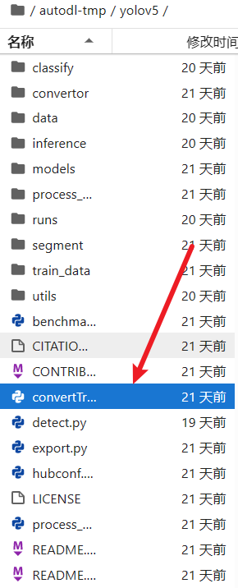
Step 4: Write the processing file, which will convert the images into a suitable image for yolov5 detection and a format for the data to analyze and process.

At this point, we have completed the preliminary construction of the environment, and then we need to start training the model。
·Model training
Step 1: In the data folder, create a new file named coco_fabtic.yaml to set the data. This file is mainly used to determine the number of categories and the name of the categories.
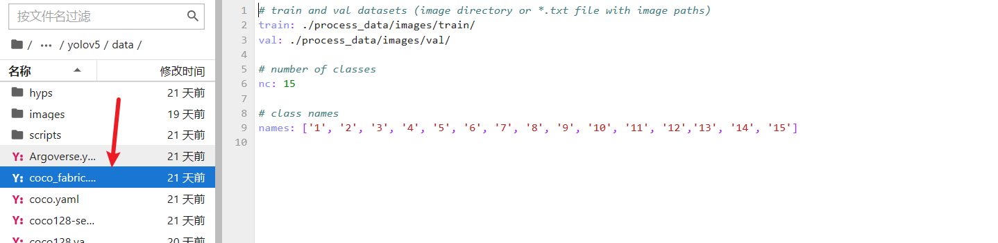
Step 2: Under the models folder, create a yolov5_fabric.yaml file to set up the model. This file is the body of the trained model, you can see the main structure of the network, the head, the neck, etc.
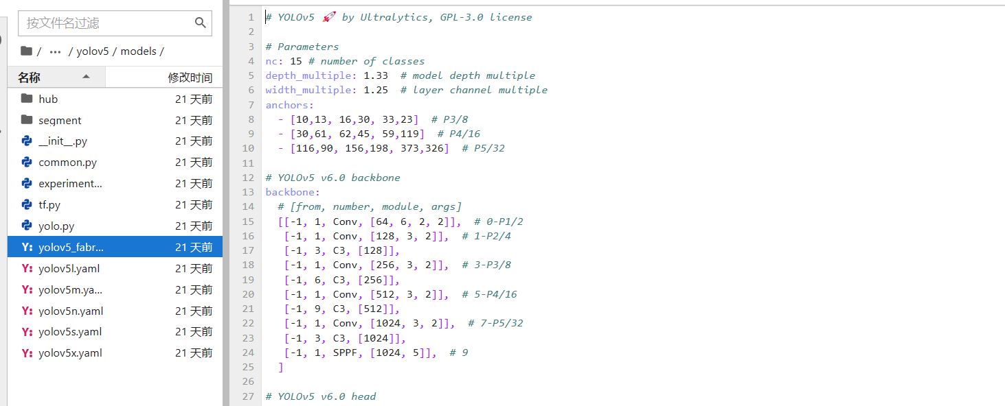
Step 3: Train the model in the terminal. Our group sets the batch-size to 8 and trains for 100 epochs. Finally, we will get two trained weight files, namely best-pt and last-pt.and this completes the basic model training phase.
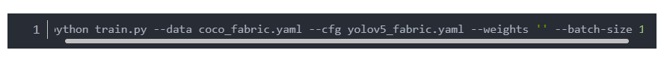
·Model detecting
Modify the detect.py file in the root directory of the project, replace the parameters in it with the model parameters we have trained, and then run the file to get the final detection results.
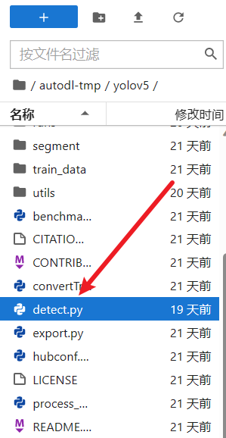
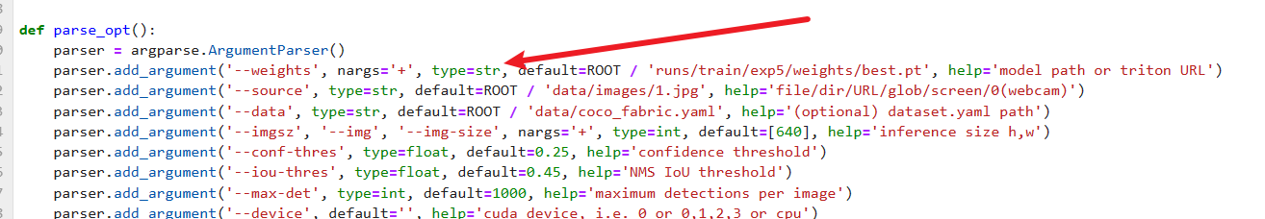

Display of results

Training stage results display
Good results were obtained in the training phase of the project. The following is a brief presentation of some results.
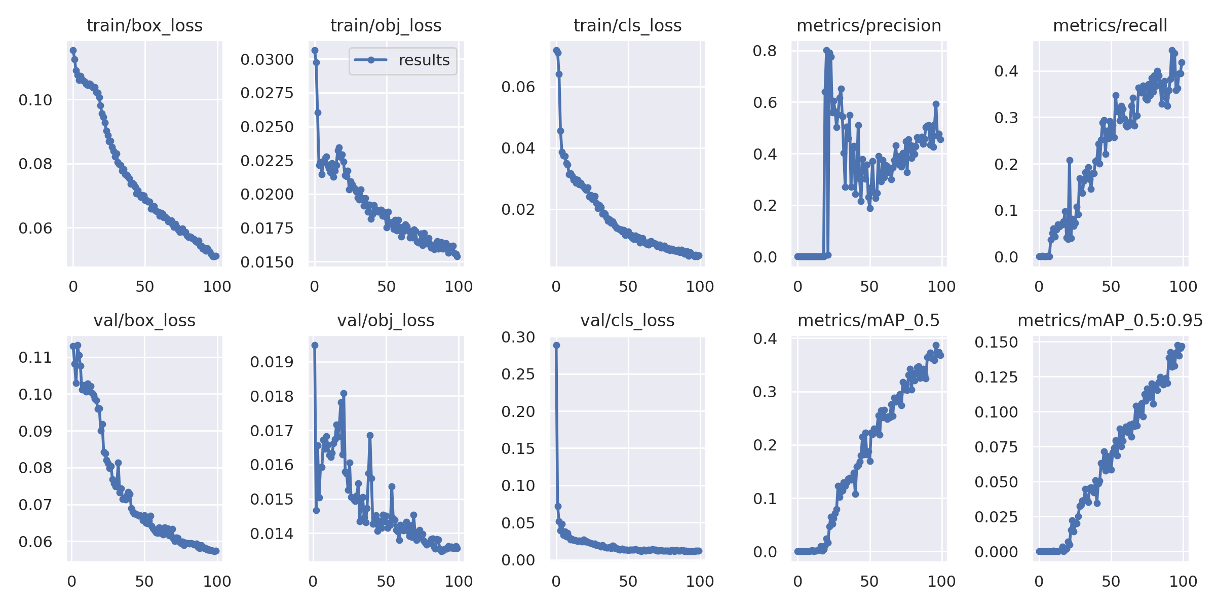
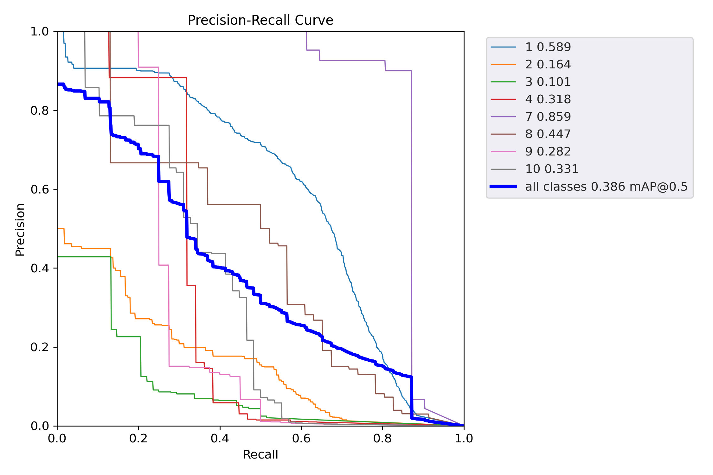

In the detection phase of this project, we took several pictures of target detection. Below are several pictures of cloth detection.
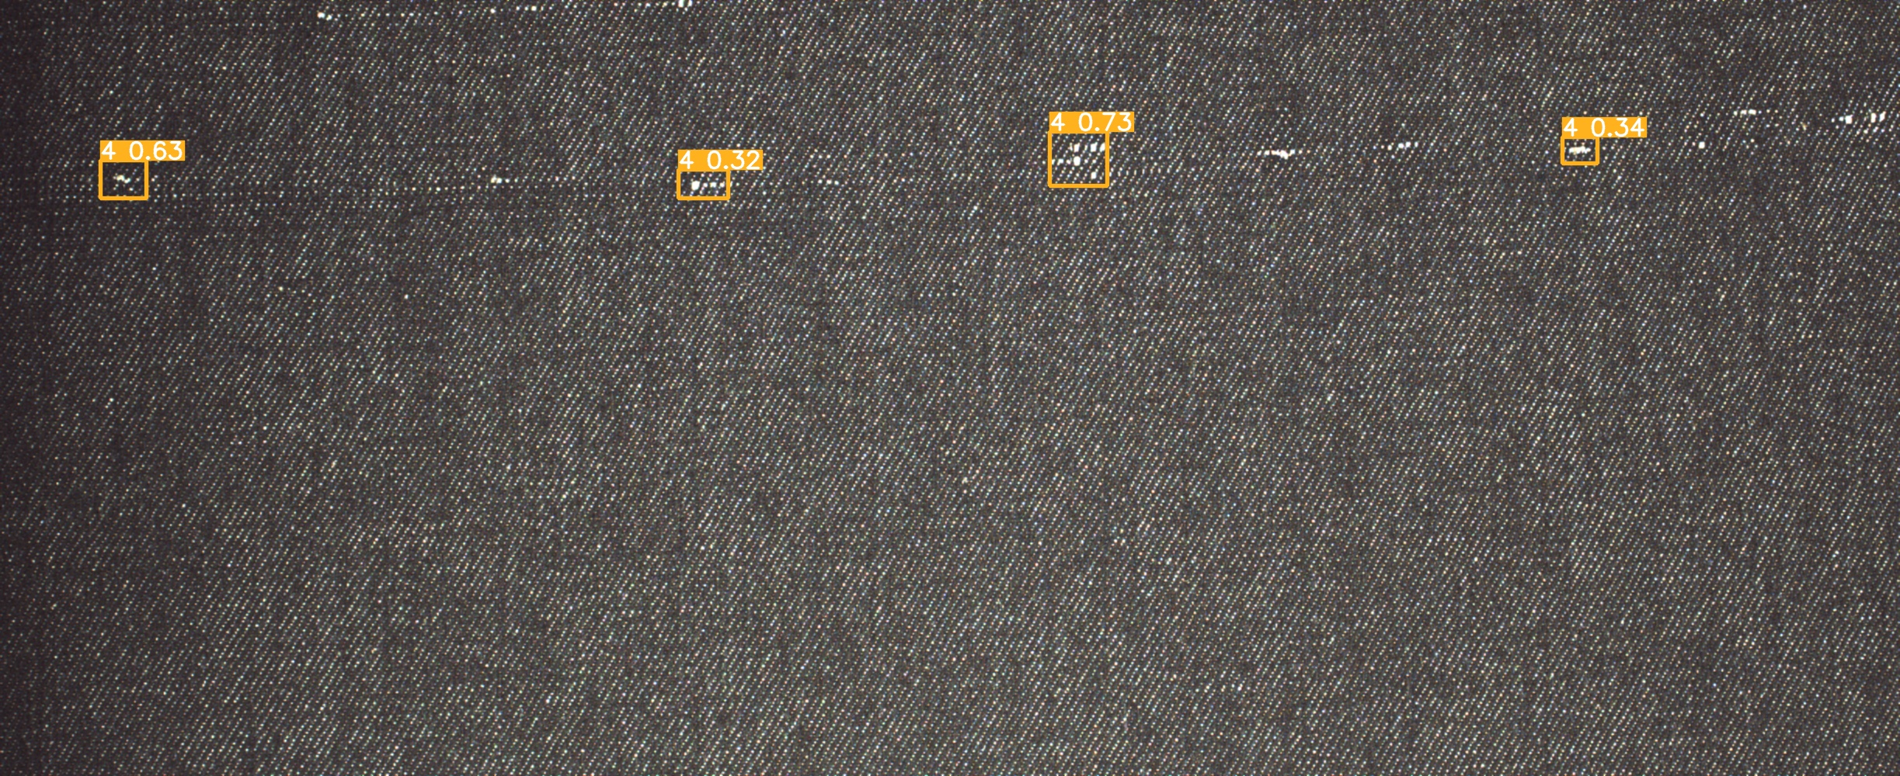
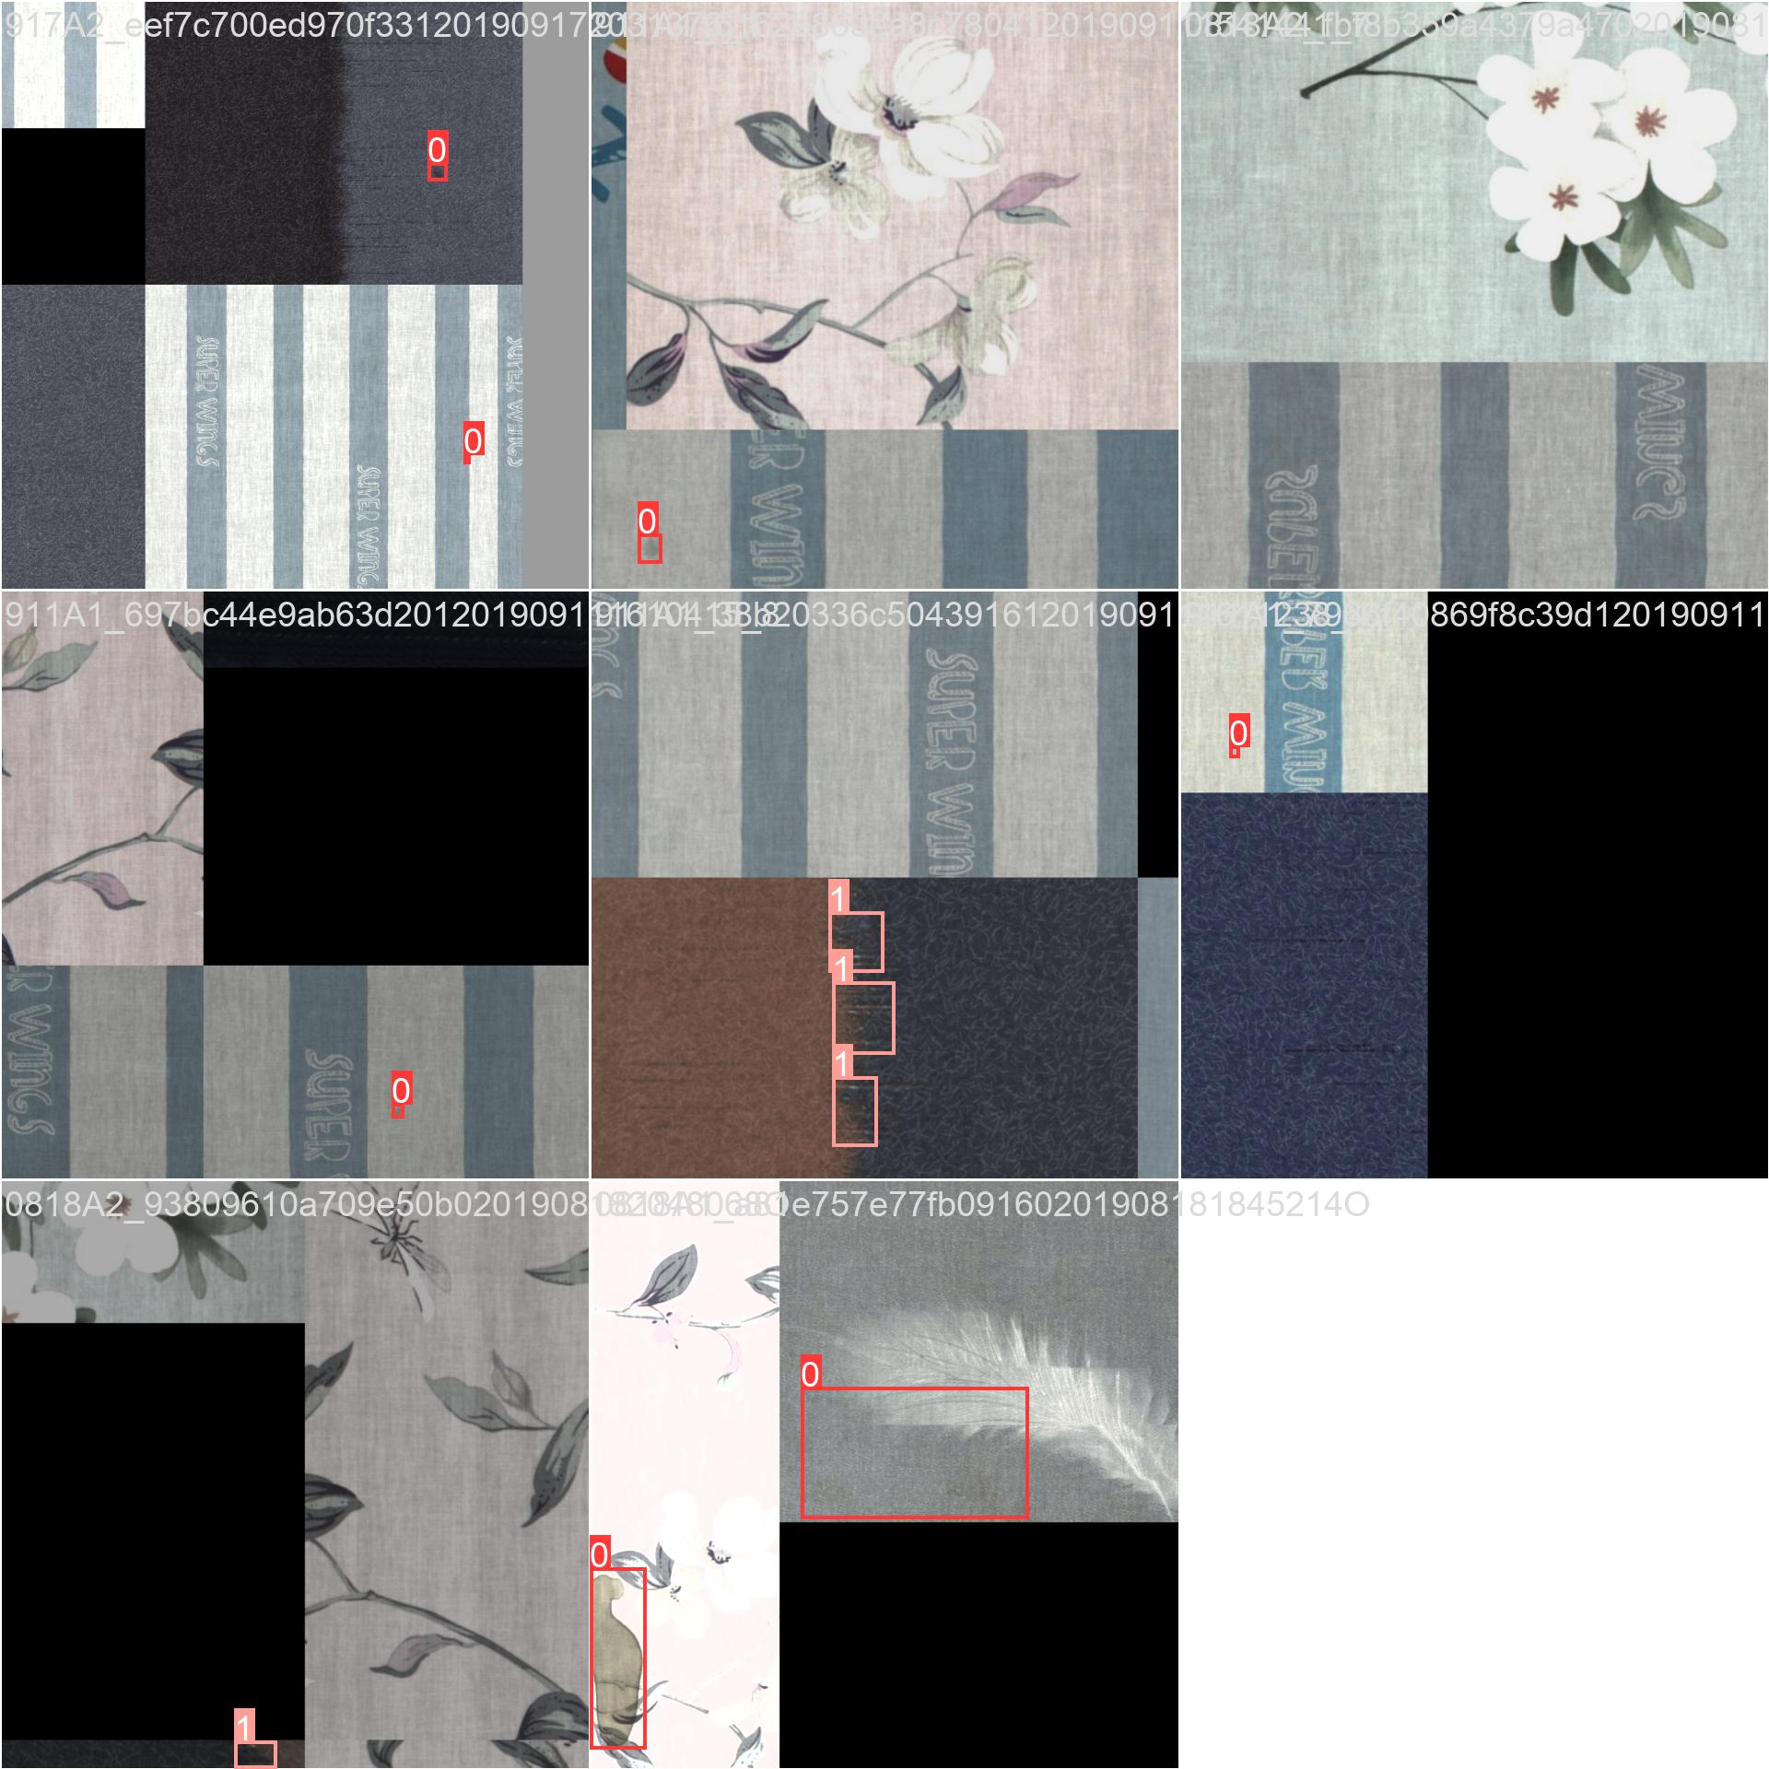

Development environment
Development platform:Pycharm,AutoDl
Development language:Python

Risk Management

The change trend of risk coefficient in the project phase
Project  Phase  Risk  statement | Requirements | Analysis | Design | Encoding | Testing | Implementation
风险1 | 0.50 | 0 | 0 | 0.2 | 0 | 0
风险2 | 0 | 0 | 0 | 0.5 | 0 | 0

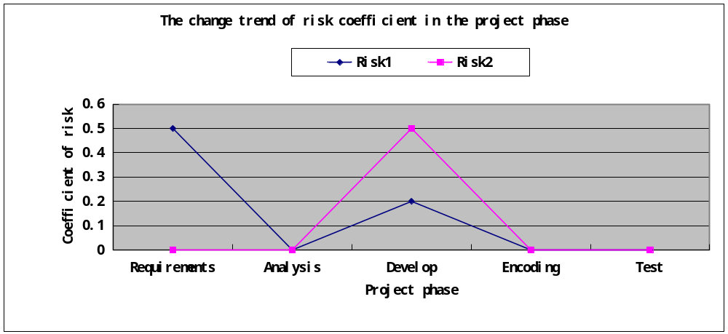

WorkLoad

Workload profile
- Project workload
Number of project team | 4 Numbers
Estimated workload | 104 person days = 832 person hours (104x8)
Actual workload | 900 person hours = approximately 225 person days
Total workload deviation | 68 person hours
Total workload deviation rate | 0.0817%

2）Total workload deviation rate：
Someone in our group is sick.
3）Measures for improvement：
Put off the plan.

Workload distribution
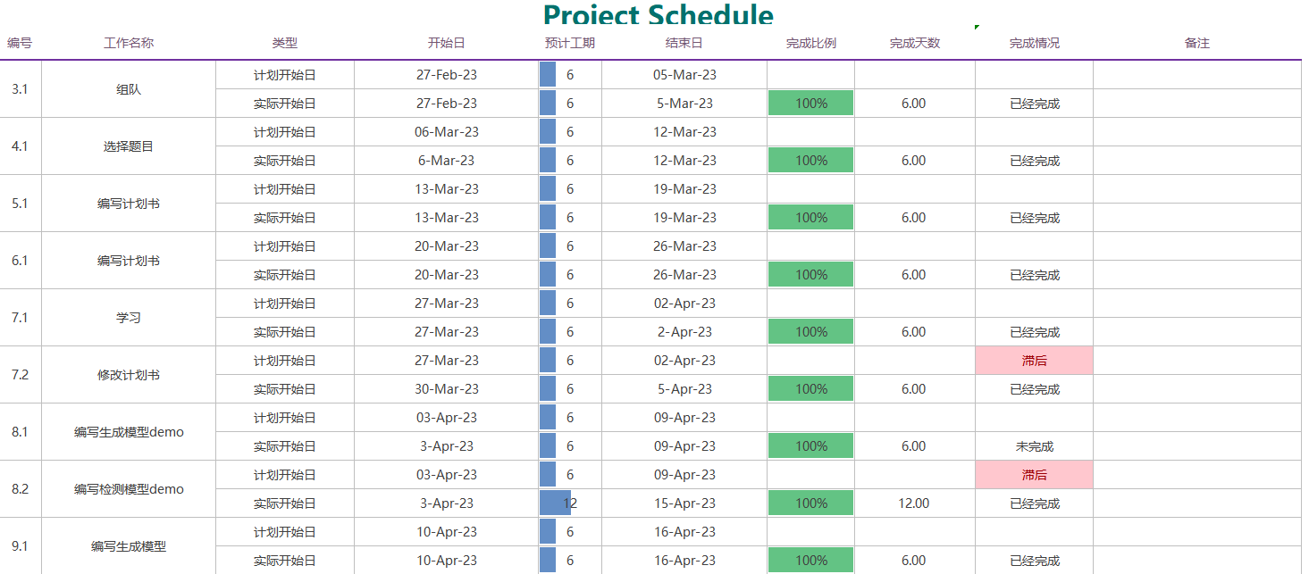
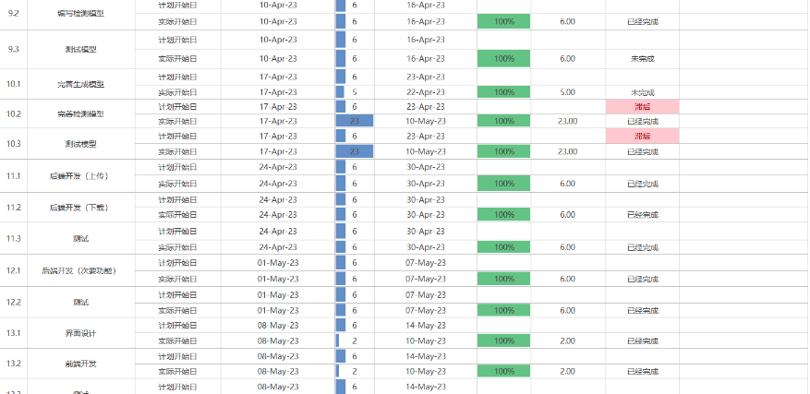
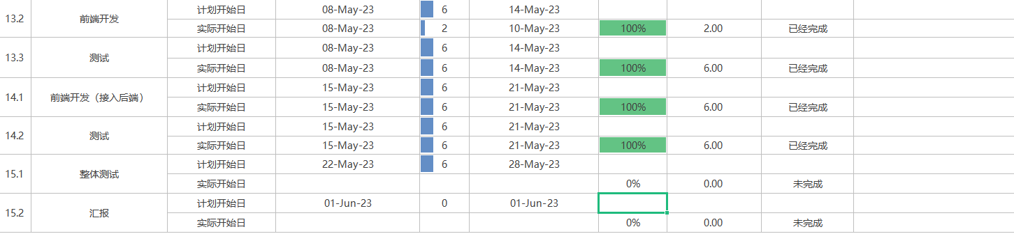

7.3 Milestone Description
Time | Milestone | Description
Sprint 1
Week3 | Team leader submits team list.
Week 4 | Team leader submits the project and a brief description on the online document.
Week 5  Week 6 | Team leader submits the project plan | Team leader submits the project plan at week 7.
Week 7. | Everyone must submit a report about what you have learned in this week.
Week 8 | The member who is responsible for the model submits a demo. | The demo must be runnable and the member must submit the outcome of the demo.  The outcome must be a picture or a document which shows the result of the model.  For detect model, the demo need to detect something.  For generative model, the demo need to genrate something.
Week 9  Week 10 | The member who is responsible for the model submits the complete model. | The model is used to solve most of the real problem we proposed.  The model contains of souce code ,the parameter and outcome.  The outcome must be a picture or a document which shows the result of the model.  For detect model, the model need to detect the fabric defect and generate a picture with the result.  For the first generative model, it need to generate a low-qulity picture.  If the first generative model can not solve the problem, member need to submit the second generative model which can transfer a low-quality picture to a high-quality one.
Sprint 2
Week 11  Week 12 | The member submits the a module of the server. | The module can be used to solve the corresponding requirement.  The main module need to upload the picture to the server and download the picture from the server.
Week 13  Week 14 | The member submits the a module of web page. | The module can be used to solve the corresponding requirement.  User can use the web page to download and upload picture for detect.  User can use the web page to generate a picture for preview.
Week 15  Week 16 | The teams submit the system and all of the document. | The team give the presentation of the system.

Cost
1）Time cost situation
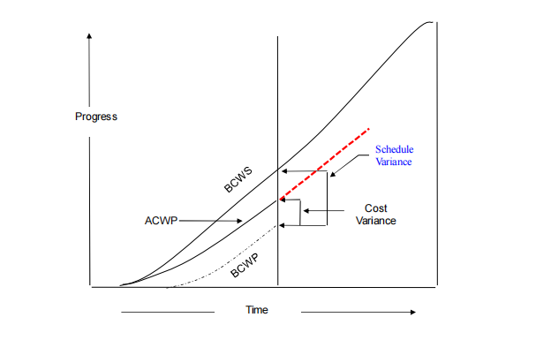
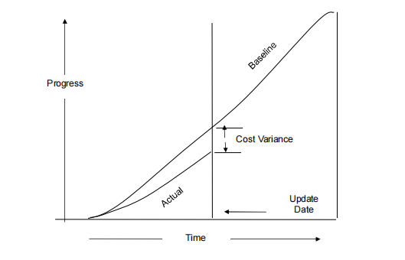
2）Explanation of deviation：
The implementation of the design project took more time than planned, and there were many modules that did not work well
3）Measures for improvement：
Update the plan and increase the investment of manpower

Test
Here's a partial test of the project.It's a test of an interface
- Login Test

Test Case | User is Null
Input | Expected | Actual
User(null) | {"status":500,"msg":"input user is null"} | {"status":500,"msg":"input user is null"}

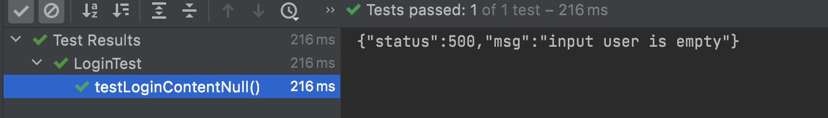

Test Case | User is not exist
Input | Expected | Actual
User(uid=1123,  username=xyc123,  pwd=19991208) | {"status":500,"msg":"user is not exist"} | {"status":500,"msg":"user is not exist"}
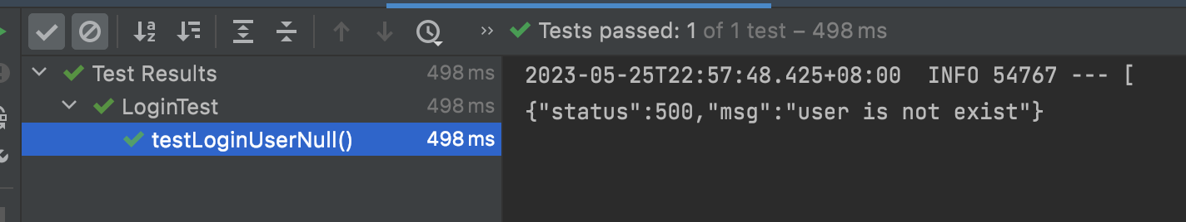

Test Case | Pwd is wrong
Input | Expected | Actual
User(uid=1,  username=xyc,  pwd=19991208) | {"status":500,"msg":"password is wrong"} | {"status":500,"msg":"password is wrong"}
User(uid=1,  username=xyc2,  pwd=dfasdasasdas) | {"status":500,"msg":"password is wrong"} | {"status":500,"msg":"password is wrong"}

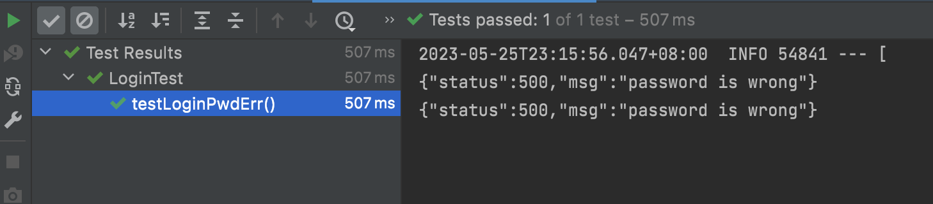

Test Case | Login Success
Input | Expected | Actual
User(uid=1,  username=xyc,  pwd=123) | {"status":200,"msg":"1"} | {"status":200,"msg":"1"}
User(uid=2,  username=xyc2,  pwd=xycxyc2023) | {"status":200,"msg":"2"} | {"status":200,"msg":"2"}
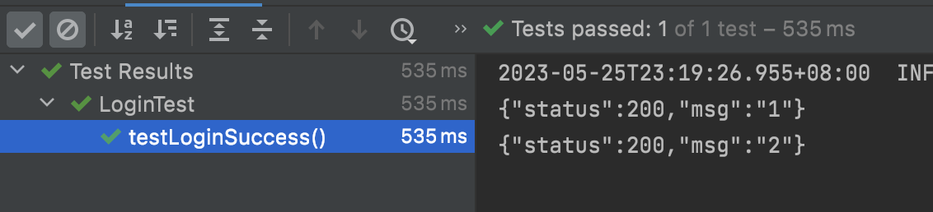

Project Summary
On the whole, our project was a success, and all the planned function points were available, but there were still many shortcomings. There were many function points and modules that were not as good as expected. For example, the accuracy of the object detection model was not high enough, the quality of the generation model was not good enough, and the front-end and back-end were also simple.

